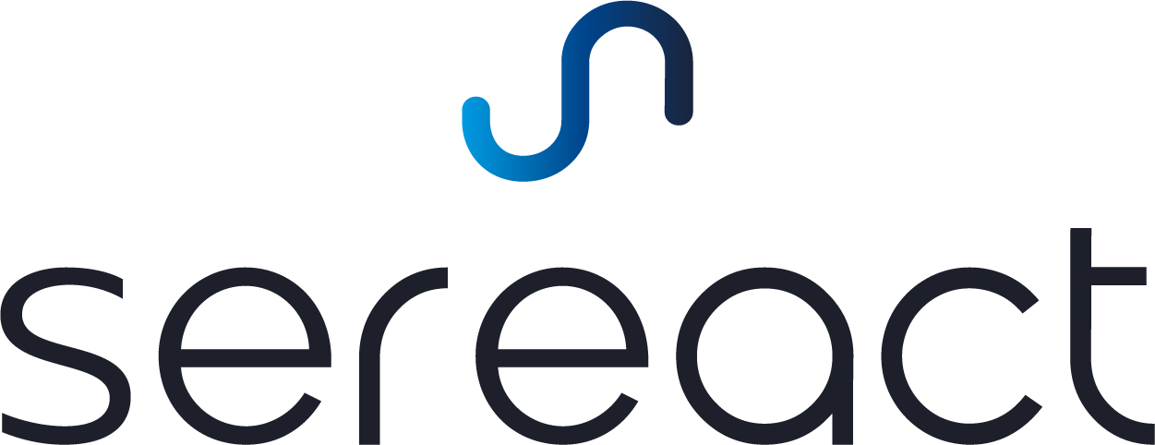

**API Integration**

**Agravis**



# Description

This document describes the integration API between **Agravis** and the **Robot Depalletizing Station**. This API adheres to the JSON-RPC 2.0 Specification, accessible at <https://www.jsonrpc.org/specification>, and operates through a single HTTP POST endpoint for sending commands with parameters. All API calls are synchronous, blocking until the system completes the execution of the specified function.

## Outline

The primary communication between Sereact and Customer is conducted via REST/JSON APIs:

* **Request Ready (Agravis** → **Sereact):**
  + The Customer requests state of the the Robotic Station
  + Returns success if robot is ready for operation
* **Pick Request - Execution Call (Agravis** → **Sereact):**
  + The Customer requests to start picking from a specific pallet to a specific target bin.
  + The Robot Station provides the status of a pick job with target bin status

# API Endpoints

## Request Ready

Customer → Sereact

This method will call the robot to check if the station is ready to perform picking tasks.

### Example Request

****{

"jsonrpc": "2.0",

"id": 1,

"method": "robot.check_ready",

}

}

**Parameters:**

* Method: robot.check_ready to validate robot is ready

### Expected Result

****{

"jsonrpc": "2.0",

"result": {

"success": true,

}

}



## 

## 

## 

## 

## 

## Pick Request - Execution Call

Customer → Sereact

This method will call the robot grasp from a pallet and place it into the target bin.

{

"jsonrpc": "2.0",

"id": 2,

"method": "robot.grasp_until_empty",

"params": {

"palletId": "qrf343",

"pickArea": "pick_1",

"placeArea": "place_1"

}

}

**Parameters:**

* id: UUID
* method: robot.grasp_until_empty
* params:
  + palletId: Information related to the pallet docked to the pick area.
  + placeArea: Designated area for placing the grasped items.
  + pickArea: Designated area for picking items.

### Pick Response - Success

Sereact → Customer

The Robot Station provides the final status of a pick request. We will respond back after a few picks when the place area is full with isTargetFull field set to true.

{

"jsonrpc": "2.0",

"result": {

"success": true,

"payload": {

"itemsPicked": 3,

"itemsPlaced": 3,

"isTargetFull": true,

"isPalletEmpty": true

}

},

"id": 2

}

**Parameters:**

* success: A boolean indicating whether the API method was called successful.
* payload: Additional details about the results, including:
  + itemsPicked:Number of items picked from the pallet.
  + itemsPlaced:Number of items placed in the target.
  + isTargetFull: Boolean indicating whether the placing is full or not.
  + isPalletEmpty:Boolean indicating whether the pallet is empty or not.

## Error Response

Sereact → Customer

Whenever a request is unsuccessful, our API will return an error response with an error type and message. You can use this information to understand better what has gone wrong and how to fix it. Most of the error messages are pretty helpful and actionable. Below is a template for an error response:

{

"jsonrpc": "2.0",

"error": {

"code": "ERROR_CODE",

"message": "ERROR_MESSAGE",

"data": {

"status": "error",

"title": "ERROR_TYPE",

"description": "ERROR_DESCRIPTION",

"itemsPicked": 1,

"itemsPlaced": 0,

"isTargetFull": false,

"isPalletEmpty": false

}

},

"id": 2

}

**Parameters**

* code: The code of the error
* message: The message from the error
* data: The data object within the error response provides additional details about the encountered error:
  + status: error
  + title: The detailed error code
  + description: The detailed description of the error.
  + itemsPicked:Number of items picked from the pallet, before the error.
  + itemsPlaced:Number of items placed in the target, before the error.
  + isTargetFull: Boolean indicating whether the placing is full or not.
  + isPalletEmpty: Boolean indicating whether the pallet is empty or not.

# Error Codes:

Sereact → Customer/HMI

Here is the list of typical error messages, codes and resolution steps:

| **Error Code** | **Code** | **Description** | **Severity** | **Resolution** |
| --- | --- | --- | --- | --- |
| -32000 | E_STOP_TRIGGERED | Emergency stop was activated. Operation halted for safety reasons. | Critical | Inspect the reason for the emergency stop activation. If all clear, release the emergency stop. Resume the system by dragging the resume button. |
| -32001 | SAFETY_GUARD_VIOLATION | A safety guard was breached. The robot is in safe stop. | Critical | Inspect the doors and the safety system. Ensure the doors are closed and the cell is empty. If all clear, the system will ask for visual confirmation. Follow the instructions on the screen. |
| -32002 | FENCE_SAFETY_GUARD_FAILURE | The fence safety guard system has failed or is not connected. The robot is in safe stop. | Critical | Inspect the doors and the safety system. Ensure the doors are closed and the cell is empty. If all clear, the system will ask for visual confirmation. Follow the instructions on the screen. |
| -32003 | SOFTWARE_ERROR | A software fault occurred, possibly due to a bug or unexpected condition. | Critical | Call the second line of support. For 2nd line: Contact Sereact's support team. |
| -32004 | DUPLICATE_ID | Station got duplicated requests | Operational | No action needed. This is an operational warning. |
| -32005 | ROBOT_FAILURE | The robot is not responding or is disconnected from the control system. | Critical | Call the second line of support. For 2nd line: Call Sereact's support team. |
| -32007 | HARDWARE_FAILURE | Failure of <components> | Critical | Call the 2nd line of support. For 2nd line: Contact Sereact's support team. |
| -32009 | GRIPPER_FAILURE | Gripper malfunctioned, possibly due to misalignment or mechanical issue. | Operational | Call the second line of support. For 2nd line: Contact Sereact's support team. |
| -32010 | PICK_FAILURE | The robot failed to pick up the object, possibly due to incorrect positioning. | Operational | No action needed. This is an operational warning. |
| -32011 | PLACE_FAILURE | The robot failed to place the object at the designated location. | Operational | No action needed. This is an operational warning. |
| -32012 | PLACE_FAILURE_UNSAFE | The robot failed to place the object at the designated location. | Critical | Human Intervention. Check the Placing Position |
| -32013 | BARCODE_SCANNER_FAILURE | The barcode scanner is not functioning or disconnected, affecting operation. | Operational | Monitor the barcode state on the HMI's 'Testing' page. Call the 2nd line of support. For 2nd line: Check the cables for the barcode scanner. For 2nd line: If the issue persists, contact Sereact's support team. |
| -32014 | CAMERA_FAILURE | The camera system is not functioning, possibly affecting object recognition or positioning. | Operational | Call 2nd line of support. For 2nd line: Check the cables. For 2nd line: If the issue persists contact Sereact's support team. |
| -32015 | BARCODE_SCAN_FAILURE | The barcode scanner is unable to read correct barcodes, affecting operation. | Operational | Monitor the barcode state on the HMI's 'Testing' page. Call the 2nd line of support. For 2nd line: Check the cables for the barcode scanner. For 2nd line: If the issue persists, contact Sereact's support team. |
| -32016 | SOURCE_BIN_EMPTY | The bin from which the robot was supposed to pick an item is empty. | Operational | No action needed. This is an operational warning. |
| -32019 | TARGET_BIN_INBOUND_FAILURE | The target bin failed to inbound. | Critical | Human Intervention. Check the Inbound Position. |
| -32020 | TARGET_BIN_OUTBOUND_FAILURE | The target bin failed to outbound. | Critical | Human Intervention. Check the Inbound Position. |
| -32021 | TARGET_BIN_FULL | The bin from which the robot was supposed to place an item is full. | Operational | No action needed. This is an operational warning. |
| -32022 | ITEM_DROPPED_SAFE | The robot dropped the item during the pick or place operation. | Operational | No action needed. This is an operational warning. |
| -32023 | ITEM_DROPPED_UNSAFE | The robot dropped the item during the pick or place operation. | Critical | Human Intervention. Clear the area ... |
| -32024 | INCOMPATIBLE_ITEM | Station received incompatible items that cannot be picked with the current configuration. | Operational | No action needed. This is an operational warning. |
| -32025 | MISSALIGNED_COMPONENTS | The Station is missing <key component> to operate. | Critical | Human Intervention. Please make sure <component> is available. |
| -32026 | MAINTENANCE_MODE_ACTIVE | The system is in maintenance mode | Maintenance | For 2nd line: Please turn the key-switch to exit the maintenance mode. |
| -32027 | FIRE_ALARM_TRIGGERED | Fire alarm triggered | Critical | Follow standard evacuation procedures. |
| -32029 | AIR_PRESSURE_IS_LOW | Air pressure is low | Critical | Call the 2nd line of support. For the 2nd line: Check the air pressure at the compressor. |
| -32030 | WMS_COMMUNICATION | Error with the WMS communication | Critical | Call the 2nd line of support. For 2nd line: Try to press the confirm button. For 2nd line: If the issue is not resolved contact Sereact's support team. |